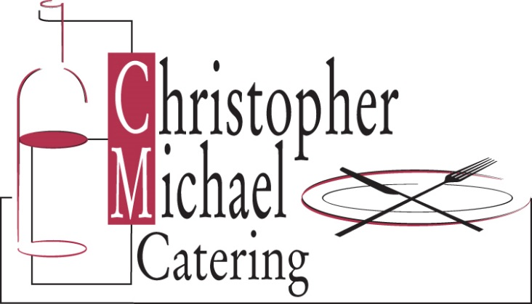

Beverage Service

Pick One

Preferred
Liquor and Mixers
Ketel One & Tito’s Vodka, Tanqueray Gin, Bacardi Rum, Dewar’s White Label, Jack Daniels
Local Chardonnay, Merlot, Cabernet Sauvignon and Pinot Grigio
Beer
Bottled Heineken, Budweiser Light & Corona (Select 2)
Assorted Soft Drinks & Juice

Premier +5
Liquor and Mixers
Ketel One, Grey Goose, Tito’s Vodka, Tanqueray, Bacardi, Captain Morgan, Maker’s Mark, Johnnie Walker Black, Jameson, Casamigo Blanco
Local Chardonnay, Merlot, Cabernet Sauvignon and Pinot Grigio
Beer
Bottled Heineken, Budweiser Light & Corona (Select 2)
Assorted Soft Drinks & Juice
Specialty Drinks +3

